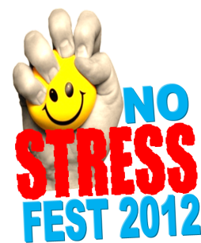
Schedule of Events
November 8, 2012

1:00 – 1:30 Guided Relaxation & Meditation Michael Newton

1: 45 – 2:15 Music
Nick Hamlyn

2:30 – 3:00 Massage & Self- Massage
Academy Canada

3:15 – 3:45 Relax through Therapeutic Art
Sandra Hewitt-Parsons

4:00 – 4:30 Make Homemade Hand/Facial Scrubs Lorraine Poole

4:45 – 5:15 Hands-on Food/Healthy Lunch Demo

5:30 – 6:00 Music
Justin Mahoney

6:15 – 6:45 Comedy Corner
Gerri Lynn Mackey

6:45 – 7:30 Zumba
Humber Community YMCA

All-Day Kids’ Corner Events (Face painting, kite/puppet making & more!

Enjoy Mocktails, Smoothies & Fruit Lollipops!
Complete the Passport Event & Enter for a Chance to Win a 2 Night Stay at the Delta in St. John’s.
Schedule of Events
November 8, 2012

1:00 – 1:30 Guided Relaxation & Meditation Michael Newton

1: 45 – 2:15 Music
Nick Hamlyn

2:30 – 3:00 Massage & Self- Massage
Academy Canada

3:15 – 3:45 Relax through Therapeutic Art
Sandra Hewitt-Parsons

4:00 – 4:30 Make Homemade Hand/Facial Scrubs Lorraine Poole

4:45 – 5:15 Hands-on Food/Healthy Lunch Demo

5:30 – 6:00 Music
Justin Mahoney

6:15 – 6:45 Comedy Corner
Gerri Lynn Mackey

6:45 – 7:30 Zumba
Humber Community YMCA

All-Day Kids’ Corner Events (Face painting, kite/puppet making & more!

Enjoy Mocktails, Smoothies & Fruit Lollipops!
Complete the Passport Event & Enter for a Chance to Win a 2 Night Stay at the Delta in St. John’s.

